3 User Scenarios
3.1 Use Cases - Table
Table 1 Use case ——View resources
Use case | View resources
Primary Actor | Students、Teachers
Intention in Context | To view the resources uploaded by others
Precondition | User has already logged in.
Trigger | User decides to view the resources
Scenario | - User clicks the resources viewing function on the interface.  - Server returns the category list.  - User chooses the specific category.  - Server returns the resource list under this category.  - User chooses the specific resource.  - Server returns the information of the resource and download link.
Abnormity | - The browser does not respond after clicking.  - The browser gives an error page:  A. Wrong content  B. Error, eg. Page not found  - User does not have privilege of viewing.  - Authentication timeout.
Priority | Must be implemented
When available | User has privilege of viewing
Use frequency | Frequent
Usage mode | By the web browser.
Unsolved problems | - How to classify the uploaded resources ?  - How to decide whether the user has the privilege of viewing ?

Table 2 Use case ——Upload resources
Use case | Upload resources
Primary Actor | Students、Teachers
Intention in Context | To upload the resources to a category
Precondition | User has already logged in.
Trigger | User decide to upload the resources
Scenario | - User clicks the resources viewing function on the interface.  - Server returns the resource uploading pages.  - User fills the uploading form and submit.  - Server returns the success message or fail message.
Abnormity | 1. The browser does not respond after clicking.  2. The browser gives an error page:  A. Wrong content  B. Error, e.g. Page not found  3. User does not have privilege of uploading.  4. Authentication timeout.  5. User enters the wrong information into the uploading form.  6. Server returns the wrong message.  7. The resource is uploaded to the wrong category.
Priority | Must be implemented
When available | User has privilege of uploading.
Use frequency | Frequent
Usage mode | By the web browser.
Unsolved problems | - How to decide whether the user has the privilege of uploading ?  - How to store the uploader’s information ?  - Should limit the max size of uploading resources ?

Table 3 Use case ——Download resources
Use case | Download resources
Primary Actor | Students、Teachers
Intention in Context | To download the resources from a category
Precondition | User has already logged in and enter in the resource information page
Trigger | User decides to download the resources
Scenario | 1. User clicks the download link.  2. The browser starts to download.
Abnormity | 1. The browser does not respond after clicking.  2. The browser gives an error page:  A. Wrong content  B. Error, e.g. File not found  3. User does not have privilege of downloading.  4. Authentication timeout.  5. The downloading stop accidentally.  6. User gets the wrong file.  7. The download speed is very low.
Priority | Must be implemented
When available | User has privilege of downloading.
Use frequency | Frequent
Usage mode | By the web browser.
Unsolved problems | 1. How to decide whether the user has the privilege of downloading ?  2. How to generate the download link ?

Table 4 Use case ——Manage resources
Use case | Manage resources
Primary Actor | Students、Teachers
Intention in Context | To change the information of the resources uploaded by oneself.
Precondition | User has already logged in.
Trigger | User wants to manage the resources uploaded by himself/herself.
Scenario | 1. User clicks the resources management link on the interface.  2.Server returns the resources list which contains the resources uploaded by the user.  3. User choose the resource which to change.  4. Server return the resource information page with the management options.  5. User chooses the management link.  6. Server returns the management form.  7. User fills the form and submit.  8. Server returns the success message or fail message.
Abnormity | 1. The browser dose not respond after clicking.  2. The browser gives an error page:  A. Wrong content  B. Error, e.g. Page not found  3. Authentication timeout.  4. The server returns wrong message.
Priority | Must be implemented
When available | User has already upload some resources.
Use frequency | Frequent
Usage mode | By the web browser.
Unsolved problems | - Should give users all the privilege of managing the resources uploaded by themselves.  - Teacher should have a special privilege of the specific course which he is teaching.

Table 5 Use case ——Search resources
Use case | Search resources
Primary Actor | Students、Teachers
Intention in Context | To search the resources by some specific condition.
Precondition | User has already logged in.
Trigger | User wants to search the resources.
Scenario | 1. User clicks the search option and choose the search method (e.g. simple search、advanced search).  2.Server returns the search page..  3. User fills the search form and submit.  4. Server returns the resource list which contains the resources meeting the condition or return a message that no such resources.  5. User chooses the specific resource.  6. Server returns the specific information of the resource and the download link.
Abnormity | 1. The browser does not respond after clicking.  2. The browser gives an error page:  A. Wrong content  B. Error, e.g. Page not found  3. Authentication timeout.  4. The server always returns “no such resources”.  5. User enters wrong information in the search form.  6. User does not have the privilege of viewing.
Priority | Must be implemented
When available | User has the privilege of viewing.
Use frequency | Less frequent
Usage mode | By the web browser.
Unsolved problems | - What condition should be provided for searching ?  - How to implement the search function ?

Table 6 Use case ——Assign homework
Use case | Assign homework
Primary Actor | Teachers
Intention in Context | To assign homework
Precondition | Teacher has already logged in.
Trigger | Teacher decide to assign some homework
Scenario | 1. User click the homework assignment link on the interface.  2.Server returns homework assignment page..  3. User fills the assignment form and submits.  4. Server return the success message or fail message.
Abnormity | 1. The browser does not respond after clicking.  2. The browser gives an error page:  A. Wrong content  B. Error, e.g. Page not found  3. Authentication timeout.  4. The server returns wrong message.  5. User enters wrong information in the assignment form.
Priority | Must be implemented
When available | User has the privilege of assignment.
Use frequency | Less frequent
Usage mode | By the web browser.
Unsolved problems | - Should give the teachers the privilege of changing the homework which has been already assigned ?  - Should send a message to the students who have to finish the homework ?

Table 7 Use case ——Submit homework
Use case | Assign homework
Primary Actor | Students
Intention in Context | To submit homework
Precondition | Student has already logged in.
Trigger | Teacher decide to assign some homework
Scenario | 1. User click the homework submission link on the interface.  2. Server returns the list of homework.  3. User choose the specific homework to submit.  4. Server return the information of the homework and the submit option.  5. User choose the file to upload and submit.  6. Server return the success message or fail message.
Abnormity | 1. The browser does not respond after clicking.  2. The browser gives an error page:  A. Wrong content  B. Error, e.g. Page not found  3. Authentication timeout.  4. The server returns wrong message.  5. Current date is after the deadline of the homework.
Priority | Must be implemented
When available | Teachers have assigned some homework
Use frequency | Less frequent
Usage mode | By the web browser.
Unsolved problems | 1. Should allow students to submit the same homework twice or more times ?

Table 8 Use case ——Check homework
Use case | Assign homework
Primary Actor | Teachers
Intention in Context | To check homework
Precondition | Teacher has already logged in.
Trigger | Teacher decide to check the homework upload by students
Scenario | 1. User click the homework check link on the interface.  2.Server returns homework list which contains the homework assigned by the user..  3. User chooses the specific homework.  4. Server return information of the homework and the submission list.  5. User choose the student’s homework form the submission list.  6. The browser starts to download.
Abnormity | 1. The browser does not respond after clicking.  2. The browser gives an error page:  A. Wrong content  B. Error, eg. Page not found  3. Authentication timeout.  4. The server returns wrong message.  5. The downloading stop accidentally.  6. User gets the wrong file.  7. The download speed is very low.
Priority | Must be implemented
When available | Students have submitted homework
Use frequency | Less frequent
Usage mode | By the web browser.
Unsolved problems | 1. Should provide a simple score and evaluate function ?  2. If a student submit the homework again, should send a message to the teacher or just make a mark on the submission list ?

Table 9 Use case ——Administration
Use case | Administration
Primary Actor | Administrators
Intention in Context | To manage all the resources and homeworks.
Precondition | Administrator has already logged in.
Trigger | Administrator wants to manage the resources
Scenario | 1. Administrator clicks the resources management link on the interface.  2.Server returns the resources viewing page with management options.  3. Administrator chooses the resource which to change.  4. Server returns the resource information page with the management options.  5. Administrator chooses the management link.  6. Server returns the management form.  7. Administrator fills the form and submits.  8. Server returns the success message or fail message.
Abnormity | 1. The browser does not respond after clicking.  2. The browser gives an error page:  A. Wrong content  B. Error, e.g. Page not found  3. Authentication timeout.  4. The server returns wrong message.
Priority | Must be implemented
When available | User has already upload some resources.
Use frequency | Less frequent
Usage mode | By the web browser.
Unsolved problems | 1. The one who upload the resource might be told that the administrator has remove/change his/her files and why the files is removed/changed.

3.2 User Cases - Graph
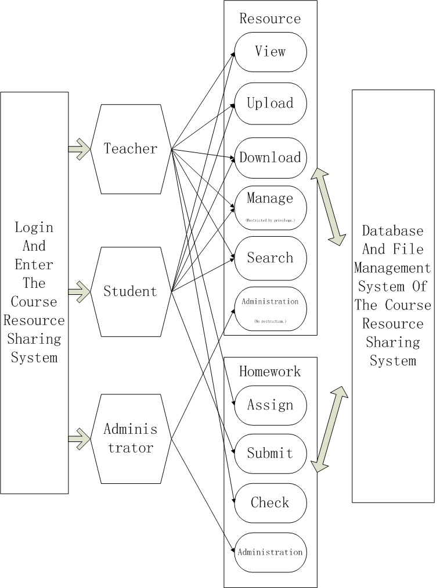

3.3 IPO Graph
Though the usage of course resource sharing system, the custom may input / output lots of files and data into the database / file management system. The following IPO graph emerges the relation of input & output and the tendency of file & data steam.
